Industry reaction to the Commission’s Delegated Act under Article 29 PPWR
The Commission’s decision to introduce a derogation for pallet wrappings and straps from the 100% reuse targets set out in Article 29(2) and (3) of the Packaging and Packaging Waste Regulation (PPWR) represents a welcome recognition of the operational challenges consistently raised by the European packaging value chain throughout the legislative process. By acknowledging these practical constraints, the Commission affirms the evidence provided by businesses across sectors, demonstrating that these packaging formats are not suitable for reuse and that, to date, no proven reusable alternatives exist at scale that can guarantee an equivalent level of load stability, product protection, transport safety, and operational reliability. Therefore, the decision to restrict this derogation exclusively to the 100% target, leaving the 40% reuse target of Article 29(1) untouched, is both inconsistent and disappointing.
Maintaining the 40% reuse target under Article 29(1) for these very same formats effectively reintroduces the same concerns regarding feasibility, safety and functionality that were acknowledged in the context of the 100% reuse targets. These challenges arise wherever palletised goods require reliable load securing during transport, storage, and handling. Pallet wrapping films must be cut upon receipt at which point they immediately lose their structural integrity and functional capacity. Similarly, pallet straps are engineered for single-use stabilisation and cannot reliably maintain performance once removed. In many industrial logistics applications, pallets carry very high loads, undergo multiple handling operations, travel long distances, and must meet strict safety requirements. In such contexts, even minor reductions in load-securing performance can create unacceptable risks for workers, compromise product integrity, and endanger transport infrastructure. These challenges are widespread and affect numerous sectors and critical European value chains.
EU Leaders have committed to simplification, enhanced competitiveness, and a regulatory framework that reinforces its industrial base. Granting a targeted exemption from the 40% reuse target for specific transport packaging formats, prioritising recyclability or recycled content where reuse is technically unsuitable, is essential to delivering on these commitments in a coherent and practical manner.
A fragmented approach would lead to a framework that is difficult to apply consistently, raises questions around legal certainty and proportionality, and creates real implementation challenges for companies. We therefore call on the Commission to prioritise the swift adoption of a delegated act exempting pallet wrappings and straps, as well as comparable transport packaging solutions, from the 40% reuse target under Article 29(1), in accordance with Article 29(18)(a) to (c). This is a necessary step to ensure that the PPWR remains workable, proportionate, and fit for purpose.
The undersigned associations:
 | Afera - The European Adhesive Tape Association
 | AGMPM - Association of Greek Manufacturers of Packaging & Materials
 | AHPI - Association of Hellenic Plastics Industries
 | A.I.S.E - International Association for Soaps, Detergents and Maintenance Products
 | ANAIP - Associación Española de Industriales de Plásticos
 | AnimalhealthEurope
 | APPLiA
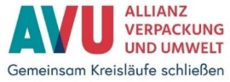 | AVU - Allianz Verpackung und Umwelt
 | Bundesverband Baustoffe - Steine und Erden e.V.
 | Cepi
 | CICPEN - Czech Industrial Coalition for Packaging and the Environment
 | CITPA - The International Confederation of Paper and Board Converters in Europe
 | Cosmetics Europe - The personal care association
 | Der Grüne Punkt
 | ECMA - The European Carton Makers Association
 | ECTA - European Core and Tube Association e.V.
 | EDANA - The Voice of the Nonwovens Industry
 | EGMF - The European Garden Machinery Federation
 | EKO-PAK - Packaging Industry Union of Employers
 | ELIPSO - Les entreprises de l’emballage plastique et souple
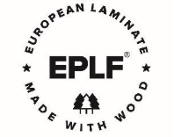 | EPLF - European Producers of Laminate Flooring Association
 | EPPA - European Paper Packaging Alliance
 | EPTA - European Power Tool Association
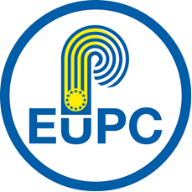 | EuPC - European Plastics Converters
 | EuPF - European Plastic Films
 | EuroCommerce
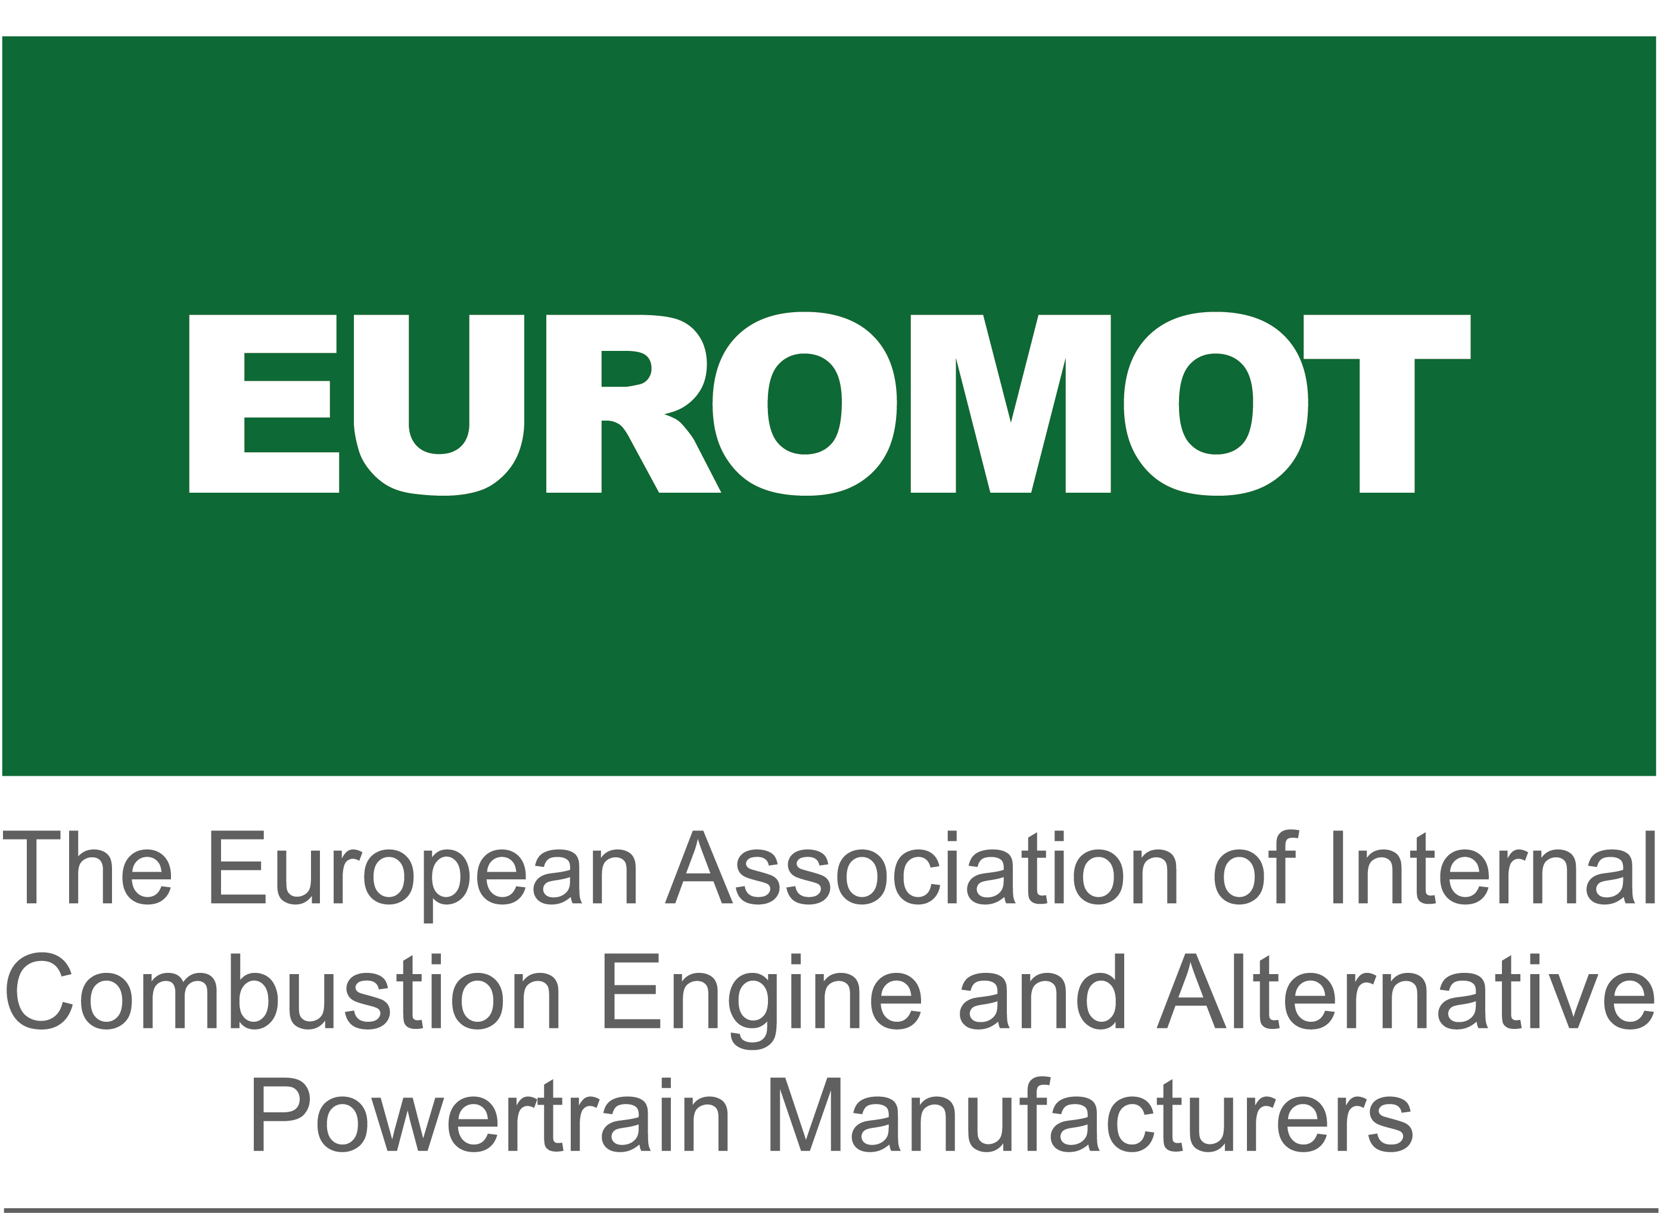 | EUROMOT - The European Association of Internal Combustion Engine and Alternative Powertrain Manufacturers
 | European Bioplastics
 | EUROPEN - The European Organisation for Packaging and the Environment
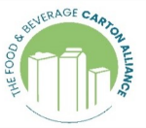 | FBCA - The Food & Beverage Carton Alliance
 | FCIO - Fachverband der Chemischen Industrie Österreichs
 | FEFCO - The European Federation of Corrugated Board Manufacturers
 | FEICA - Association of the European Adhesive & Sealant Industry
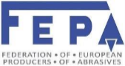 | FEPA - Federation of European Producers of Abrasives
 | FEPE - Federation of European Producers of Envelopes and Light Packaging
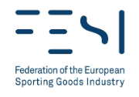 | FESI - Federation of the European Sporting Goods Industry
 | FEVE - The European Container Glass Federation
 | FINAT - The Association for the European Label Industry
 | GROUP'HYGIENE - Syndicat des fabricants de textiles sanitaires pour l'hygiène, la santé et l'essuyage
 | I&P Europe - Imaging and Printing Association e.V.
 | IHO - Industrieverband Hygiene und Oberflächenschutz e.V.
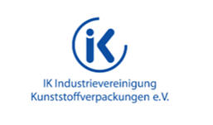 | IK - Industrievereinigung Kunststoffverpackungen e.V.
 | IKEM - Innovation and Chemical Industries in Sweden
 | IKW - Industrieverband Körperpflege- und Waschmittel e. V. / The German Cosmetic, Toiletry, Perfumery and Detergent Association
 | INCPEN - The Industry Council for Packaging & the Environment
 | Independent Retail Europe
 | Industrie-Gemeinschaft Aerosole e.V.
 | Industrieverband Garten e.V.
 | Intergraf - European Federation for Print and Digital Communication
 | IPV - Industrieverband Papier- und Folienverpackung e.V.
 | Istituto Italiano Imballaggio
 | Konfederacja Lewiatan
 | LightingEurope
 | Medicines for Europe
 | MedTech Europe - The European Trade Association for the Medical Technology Industry
 | Miljöpack
 | MMFA - Multilayer Modular Flooring Association
 | MPE - Metal Packaging Europe
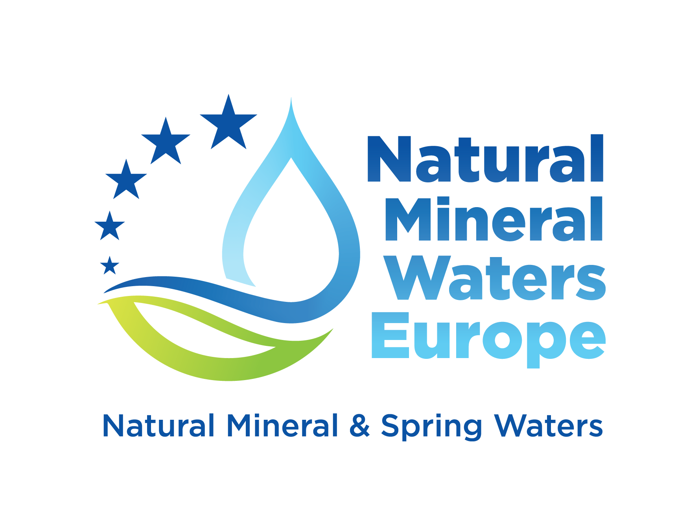 | NMWE - Natural Mineral Waters Europe
 | NRK Verpakkingen
 | PAKKAUS - The Finnish Packaging Association
 | Plastics Europe
 | Pro Carton - European Association of Carton and Cartonboard manufacturers
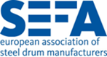 | SEFA - European Association of Steel Drum Manufacturers
 | SfPE - Steel for Packaging Europe
 | SZZV - Slovak Association for Branded Products
 | TIE - Toy Industries of Europe
 | UNESDA - Soft Drinks Europe
 | VCI - Verband der Chemischen Industrie e.V. / German Chemical Industry Association
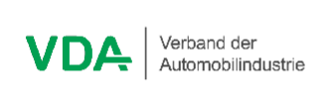 | VDA - Verband der Automobilindustrie e.V. / German Association of the Automotive Industry
 | VDGH - Verband der Diagnostica-Industrie e.V.
 | Verband der deutschen Lack- und Druckfarbenindustrie e.V.
 | VMV - Verband Metallverpackungen e.V.
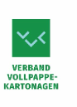 | VVK - Verband Vollpappe-Kartonagen e.V.
 | ZVEI e.V. - Electro and Digital Industry Association
 | ZVG - Zentralverband Gartenbau e. V. / German Horticultural Association
  

